FSP Large shallow piscivore Yellowtail kingfish, Samson fish, Goldband snapper, Mulloway, Barracouta

**Yellowtail kingfish** *Seriola lalandi* – no info

**Samson fish** *Seriola hippos*

Samson fish are carnivorous and their diets include both pelagic and demersal prey such as pilchards, yellowtail scad, red snappers, squid and cuttlefish.

**Goldband snapper** *Pristipomoides multidens* no info

**Mulloway** *Argyrosomus hololepidotus*

It is regarded as a benthic carnivore but can apparently feed throughout the water column (Kailola et al., 1993). The importance of different dietary components has varied among studies and for different life history stages. Overall, crustaceans, notably penaeid, mysid and alpheid shrimp, and small teleost fish have been the primary dietary items observed in the stomachs of juvenile A. japonicus (Anon, 1981a; Marais, 1984; Hall, 1986; Fielder et al., 1999). Crustaceans accounted for between 14% (Fielder et al., 1999) and 81% (Anon, 1981a) of the reported diet of juveniles. The importance of crustaceans in the diet of A. japonicus appears to decrease with increasing fish size, resulting in fish and squid being the prey of greater relative importance in larger A. japonicus (Marais, 1984; Griffiths, 1997a,b).

V. Silberschneider and C. A. Gray 2008. Synopsis of biological, fisheries and aquaculture-related information on mulloway Argyrosomus japonicus (Pisces: Sciaenidae), with particular reference to Australia. J. Appl. Ichthyol. 24 (2008), 7–17

Griffiths, M. H., 1997a: Feeding ecology of the South African Argyrosomus japonicus (Pisces: Sciaenidae), with emphasis on the eastern cape surf zone. So. Afr. J. Mar. Sci. 18, 249–264.

**Barracouta** *Thyrsites atun*

Feed on pelagic crustaceans (*Euphausia*, *Nyctiphanes*), cephalopods and fishes (Ref. [6181](http://www.fishbase.org/references/FBRefSummary.php?ID=6181)) like anchovy and pilchard (Ref. [36731](http://www.fishbase.org/references/FBRefSummary.php?ID=36731)).

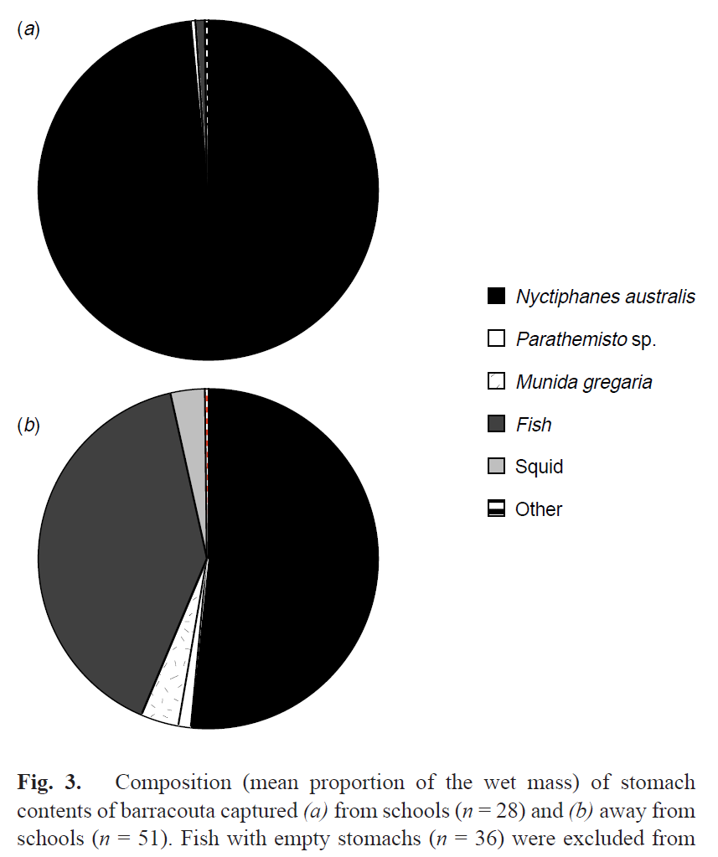

Barracouta from schools were feeding almost exclusively (98.6% by mass) on krill, *N.*

*australis*. Stomachs of only two individuals contained fish remains. The stomach contents of barracouta captured away from schools also contained a high proportion of krill (51.7% by mass), but small fish (mostly sprat, *Sprattus antipodum* and *S. muelleri*, and pilchard, *Sardinops neopilchardus*) were also important (39.9%). Three individuals also contained squid (probably *Nototodarus sloani*). Small numbers of hyperiid amphipods *Parathemisto* spp., the post-larvae of the galatheid crab *Munida gregaria*, and ‘other’ prey (mostly brachyurans) were present in some stomachs of barracouta from both groups.

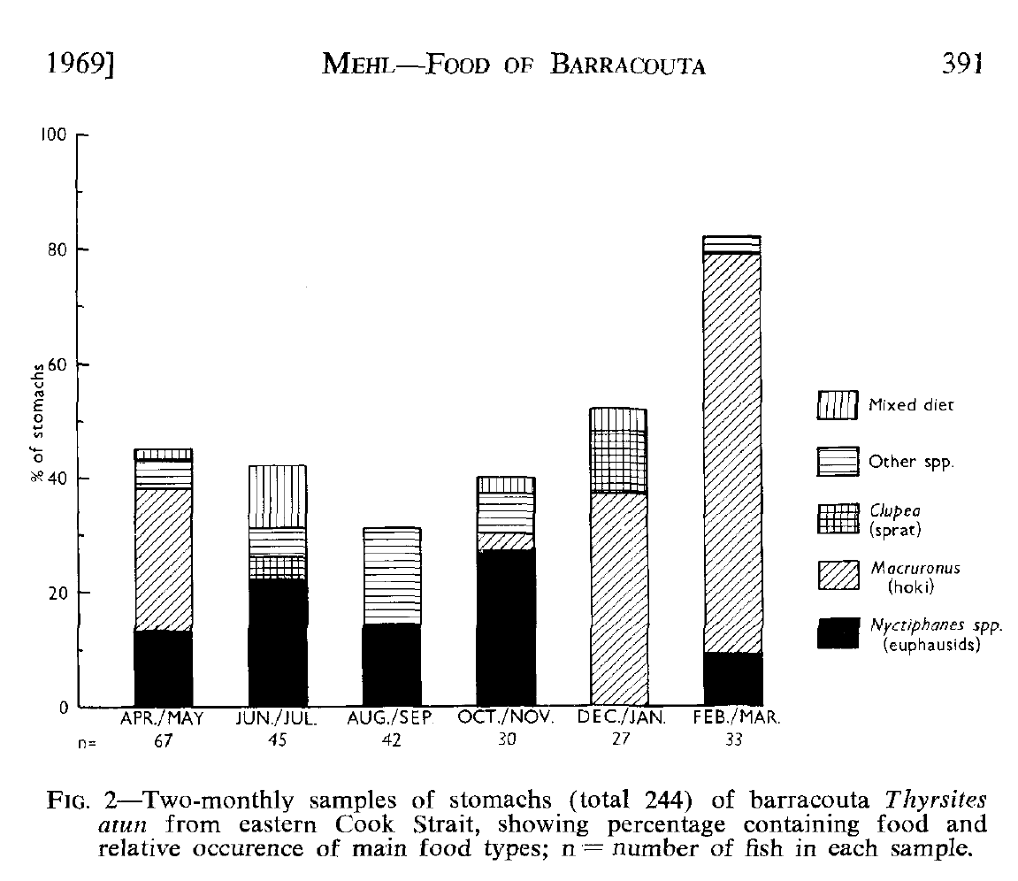

The predominance of the euphausid *Nyctiphanes australis* as a food item of barracouta supports observations made by Bary (1956), Blackburn (1957) and Grieve (1966). Phillipps (1926) also found hoki in 8 out of 12 barracouta stomachs from Palliser Bay during March and April, which supports the data in Fig. 2. Whether barracouta prefer fish to euphausids is unknown (Blackburn 1957), but the presence of both during three of the 2-month periods indicates that both items will be eaten when available. Graham (1938) listed 14 'teleosts, 3 brachyuran crustaceans, and 5 other crustaceans as food of barracouta in or neatr Otago Harbour. In Australian waters juvenile barracouta are a small yet important part of the food of the adult (Blackburn 1957), but none occurred in the adults from eastern Cook Strait.

The principal prey organisms in Bass Strait are the euphausiid *Nyctiphanes australis* Sars, the anchovy *Engraulis australis* (White), and young barracouta, in that order; and in eastern Tasmania *Nyctiphanes, Engraulis,* and the sprat *Clupea bassensis* McCulloch, in that order. The pilchard *Sardinops neopilchardus* (Steindachner) is not an important item of the diet in these regions although it is so in New South Wales, South Australia, and Western Australia. The jack mackerel *Trachurus declivis* Jenyns is a significant item in eastern Tasmania and New South Wales but not in Bass Strait.

* Euphausiids.-More stomachs contained this kind of food than any other. Only one species, Nyctiphanes australis Sars, has been recognized and it is unlikely that any other is available to a significant extent in this region; all euphausiids in the numerous plankton catches made in these waters have likewise proved to be N. australis (author, unpublished data), which fishermen call "brit" or "red feed". **(3)**
* Anchovy (Engraulis australis (White)).-This small clupeoid fish is the second most common prey species of the barracouta in this region. It probably occurred more often than it was recorded, as some observers would not have been able to recognize it in a semi-digested state and would have recorded it as "fish remains" (see (8) below) ; the same applies to other fishes. Victorian fishermen have several names for this species, the commonest being "whitebait".
* (4) Juvenile barracouta.-This was the third most common prey species. Individuals of up to 40 cm L.C.F. were obtained from the stomachs. Figure **2** shows the percentage of stomachs which contained this species in each month; it was small (not exceeding 2) in all months except April, when it reached 9, but this figure is probably abnormal (Section III(a)).
* Pilchard (Sardinops neopilchardus (Steindachner)).-This clupeoid species featured in the diet only in November and December and then in no more than 1 per cent of stomachs. As it is freely eaten by barracouta in other Australian waters (see below, especially Section II(f)) it is probably not common on this part of the open coast of Victoria, a conclusion which is supported by other data (Blackburn 1950~). (6)
* Trachurus spp.-Trachurus is a pelagic carangiform fish genus with two species in Victorian waters, T. maccullochi Nichols (T. declivis auct., non Jenyns) and T, declivis Jenyns (T. novae-zelandiae Richardson et auct.). The differences between them are small and it is generally impossible to identify part-digested specimens. Although Trachurus is a significant constituent of the diet of the barracouta in other Australian waters (Sections II(d) and II(e)) it was found in only one stomach from the southern Victorian coast and is therefore probably not common in that region.
* **(7)** Other identifiable fish.-Other fish, in condition suitable for identification but not yet identified, were found in several months of the year but never in more than 1 per cent of stomachs.
* (8) Fish remains.-Remains of fish which the observers regarded as unidentifiable were consistently found in a small percentage of stomachs. The percentage did not exceed **3** in most months but was slightly higher (4-5) in spring and reached 8 in May. As the highest percentages occurred in months when anchovies were an important item of the diet it is highly probable that many of these remains were anchovies.
* (9) Cepha1opods.-These were found in only seven stomachs and appear to be unimportant in the diet. The species, which were mainly small squid, have not been identified.
* (10) Other crustaceans.-Crustaceans other than euphausiids, which were mainly amphipods, were found in only seven stomachs. They have not been identified.

On the south coast of Western Australia (long. 118" to 129" E.) only 88 stomachs have been obtained, all in May, June, and July (1947 and 1951). This is the season of spawning and greatest availability in the coastal waters. The stomachs were 78 per cent empty, 15 per cent with pilchard (common in the area at that season; see Blackburn 1950c), and 7 per cent with other food, including ruff in one stomach only, but no euphausiids, anchovy, barracouta, or Trachurus. However, Whitley (1946) found anchovy, *Trachurus declivis*, and the true mackerel Xcomber australasicus Cuvier & Valenciennes in the stomachs of barracouta taken in this area in June. Euphausiids generally are much scarcer in the area than in the other regions previously discussed, and Nyctiphanes australis is altogether absent.

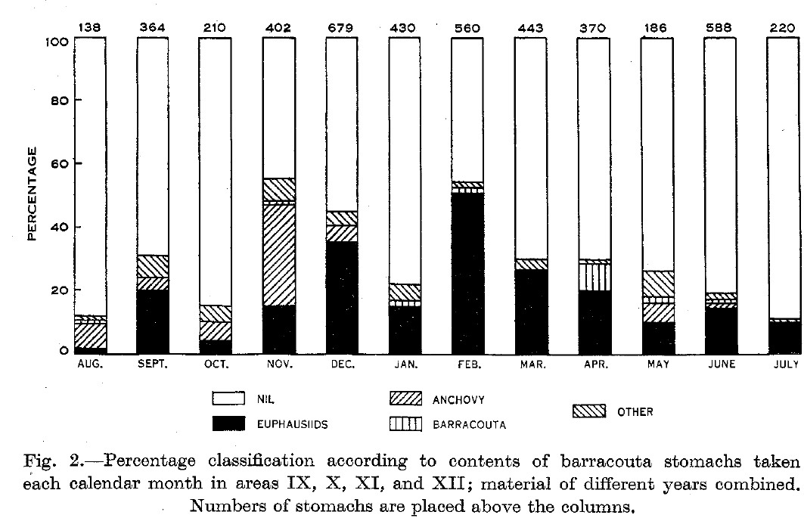

Barracouta

|  |  |
| --- | --- |
| **prey item** | **probability of consuming** |
| SAR | 0.2 |
| FSP | 0.1 |
| ZKL | 0.3 |
| FPK | 0.2 |
| CEP | 0.2 |
| ZME | 0.1 |

Mulloway juvenile

|  |  |
| --- | --- |
| **prey item** | **probability of consuming** |
| ZKL | 0.3 |
| MAZ | 0.3 |
| ZME | 0.3 |
| FSP small | 0.05 |
| FMP small | 0.05 |
| FDC small | 0.05 |
| FDO small | 0.05 |
| FDT small | 0.05 |
| FSR small | 0.05 |
| FLR small | 0.05 |
| DHU small | 0.05 |
| SAR small | 0.05 |

Mulloway adult

|  |  |
| --- | --- |
| **prey item** | **probability of consuming** |
| ZKL | 0.2 |
| MAZ | 0.1 |
| ZME | 0.1 |
| FSP small | 0.3 |
| FMP small | 0.3 |
| FDC small | 0.3 |
| FDO small | 0.3 |
| FDT small | 0.3 |
| FSR small | 0.3 |
| FLR small | 0.3 |
| DHU small | 0.3 |
| SAR small | 0.3 |

Nakamura, I. and N.V. Parin, 1993. FAO Species Catalogue. Vol. 15. Snake mackerels and cutlassfishes of the world (families Gempylidae and Trichiuridae). An annotated and illustrated catalogue of the snake mackerels, snoeks, escolars, gemfishes, sackfishes, domine, oilfish, cutlassfishes,. scabbardfishes, hairtails, and frostfishes known to date. FAO Fish. Synop. 125(15):136 p.

Bianchi, G., K.E. Carpenter, J.-P. Roux, F.J. Molloy, D. Boyer and H.J. Boyer, 1999. Field guide to the living marine resources of Namibia. FAO species identification guide for fishery purposes. Rome, FAO. 265 p., 11 colour plates.

BLACKBURN, M. 1957: The relationship between the food of the Australian barracouta *Thyrsites atun* (Euphrasen) and recent fluctuations in the fisheries. *Aust. J. mar. Freshwat. Res. 8 (1):* 29-54